Useful links (git):

[Really Simple Guide](http://rogerdudler.github.io/git-guide/)

[More Detailed Visual Guide](https://marklodato.github.io/visual-git-guide/index-en.html)

[How to collaborate on Github](https://code.tutsplus.com/tutorials/how-to-collaborate-on-github--net-34267); [Rebasing](https://git-scm.com/book/en/v2/Git-Branching-Rebasing) ; [Navigation Tree for un-messing things up](https://sethrobertson.github.io/GitFixUm/fixup.html)

**Week three Instructions:**

Today we will **fork** our own copy of the class repository on github.com and clone it to our local computers. We will then make changes to our local “working directory” before (adding, committing, and) pushing these changes to our online repo. Next week we will explore how to pull additional “upstream” changes (ie. week 4 notes) into our repository.

1. Navigate to repository
   1. <https://github.com/JohnSerences/PSYC-NEU-231>
2. **Fork**
   1. Press fork and follow prompts. This will create your own personal copy of the repository on your github account.

**\*\*\*\* Good time to clean up local computer of old versions!! \*\*\*\***

1. **Clone** repository to your local computer
   1. git desktop: File-> Clone Repository -> select repository from list you just downloaded (must be logged in)
   2. terminal/git command line: git clone XXX (link from website)
2. Make a change (add your name to README.md)
   1. Navigate to README.md file and edit with favorite text editor
   2. vim README.md 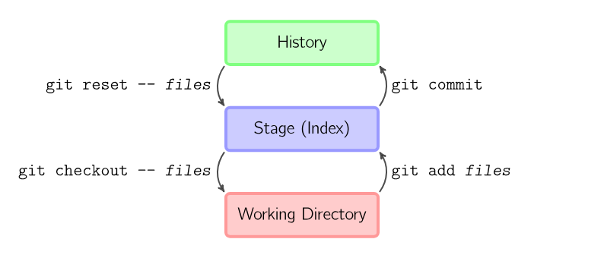
3. **Add** changed files to be “tracked”
   1. Automatically done… files can be manually selected to be “untracked”
   2. git add XX OR git add -A (all changes)
4. **Commit** changes
   1. Add message to summary field, press commit
   2. git commit -m “my message”
5. **Push** changes to remote repository (github.com)
   1. Check upstream Repository -> Repository Settings -> [should be set to your repo on github.com]
   2. Repository -> Push
   3. Check upstream: git remote -v
   4. git push
6. [**Rinse and repeat**](https://git-scm.com/book/en/v2/Git-Basics-Recording-Changes-to-the-Repository) steps 6-8 as you work on exercises before next week.